**Database Management System – cs422 DE**

**Assignment 5 – Week 6**

------------------------------------------------------------------------------------------------------------------------------------------

**This assignment is based on lecture 6 (chapter 12).**

* Submit your *own work* on time. No credit will be given if the assignment is submitted after the due date.
* Note that the completed assignment should be submitted in .doc, .docx, .rtf or .pdf format only.
* In MCQs, if you think that your answer needs more explanation to get credit then please write it down.
* You are encouraged to discuss these questions in the Sakai forum.

1. A student can take not more than 5 subjects in a semester. The number of students allowed in a subject in a semester is not more than 40. The student – subject relationship is:

(A) 5:40 (B) 40:5

(C) N:5 (D) 40:M

ANS:

C

1. Which of the following is NOT a basic element of all versions of the E-R model?

(A) Entities   
(B) Attributes  
(C) Relationships   
(D) Primary keys  
ANS:

D

1. The attribute *name* could be structured as a attribute consisting of first name, middle initial, and last name. This type of attribute is called  
   (A) Simple attribute  
   (B) Composite attribute  
   (C) Multivalued attribute  
   (D) Derived attribute  
   ANS:

B

1. Which of the following indicates the minimum number of entities that must be involved in a relationship?

(A) Maximum cardinality   
(B) Minimum cardinality  
(C) ERD

(D) Keys   
ANS:

C

1. Which of the following is a single valued attribute  
   (A) Register_number  
   (B) Address  
   (C) SUBJECT_TAKEN  
   (D) Reference  
   ANS:

A

1. In a one-to-many relationship, the entity that is on the many side of the relationship is called as  
   (A) Strong entity  
   (B) Weak entity  
   (C) Entity that has optional participation in the relationship  
   (D) Entity that has mandatory participation in the relationship  
   ANS:

C

1. Describe what attributes represent in an ER model and provide examples of simple, composite, single-valued, multi-valued, and derived attributes.   
   (Review Question 12.3 in 5th edition/ 11.3 in 4th edition)  
   ANS:

An attribute represents a property of an entity or a relationship type Examples:

Simple:positionor salaryattribute of Staff

Composite:addressattribute composed of street, city, and postcodeattributes

Single-valued:branchNoattribute of Branch

Multi-valued:telNoattribute of Branch

Derived:durationattribute of Lease, calculated from rentStart and rentFinish attributes.

1. Describe how strong and weak entity types differ and provide an example of each.   
   (Review Question 12.8 in 5th edition/ 11.8 in 4th edition)

ANS:

strong entity type is an entity type that is notexistence-dependent on some other entity type. Examples of strong entity types are Branch, Staff, and PropertyForRent.

A weak entity type is an entity type that is existence-dependent on some other entity type. An example of a weak entity type is Preference.

1. Create an ER diagram for each of the following descriptions:   
   (Exercise 12.10 in 5th edition/ 11.10 in 4th edition)
   1. Each company operates four departments, and each department belongs to one company.  
      ANS:

Operates ->

Department

Company

1

4

* 1. Each department in part (a) employs one or more employees, and each employee works for one department.  
     ANS:

Employes ->

Employee

Department

1..**\***

1

* 1. Each of the employees in part (b) may or may not have one or more dependants, and each dependant belongs to one employee.  
     ANS:

has ->

Dependent

Employee

0..*

1

* 1. Each employee in part (c) may or may not have an employment history.  
     ANS:

Employement

History

has ->

Employee

0..*

1

* 1. Represent all the ER diagrams described in (a), (b), (c), and (d) as a single ER diagram.  
     ANS:

Operates ->

Department

Company

1

4

Employs ->s ->

1

1..**\***

<- has

has ->

Employement

History

Dependent

Employee

1

0..*

1

0..*

1. Solve exercise 12.12 from the 5th edition (11.12 from the 4th edition). If time permits, solve from *a-f*. Otherwise, it’s ok if you just solve *f*.  
   ANS:

(a) Identify the main entity types of the DVD rental company.

* + branche ; branche_address , DVD , DVD_categorie ,DVD_copi , Staff ,member, Actor , Director

(b) Identify the main relationship types between the entity types described in part (a) and represent each relationship as an ER diagram.

branch has branch_address

branch has staff

staff manage branch

branch has DVD

DVD has DVD_copy

Branch contain member

membre rent DVD_copy

DVD has Actors

DVD has Director

***\*ER Diagramme for each relashionType:***

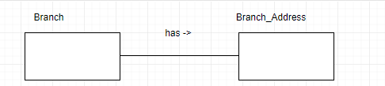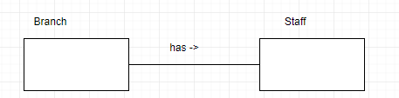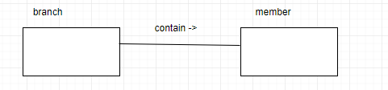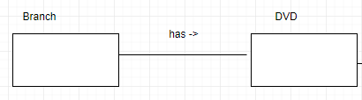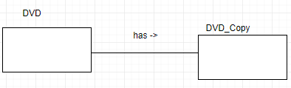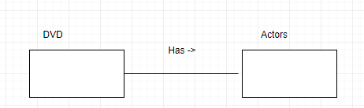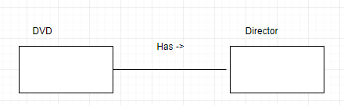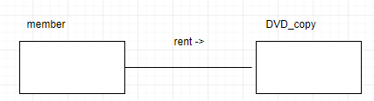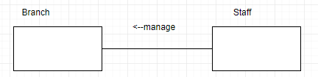

(c) Determine the multiplicity constraints for each relationships described in part (b). Represent the multiplicity

for each relationship in the ER diagrams created in part (b).

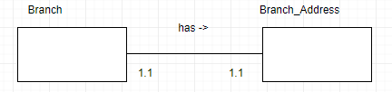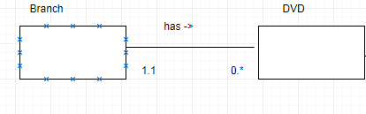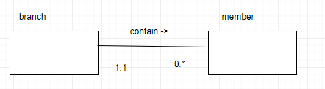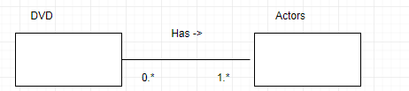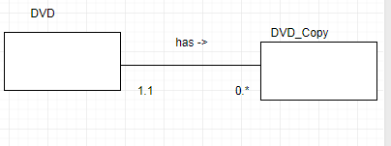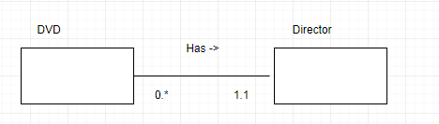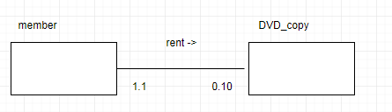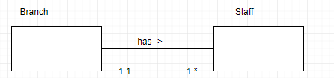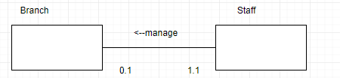

(d) Identify attributes and associate them with entity or relationship types. Represent each attribute in the ER

diagrams created in (c).

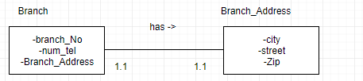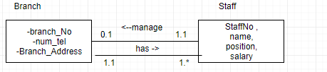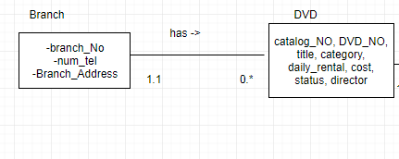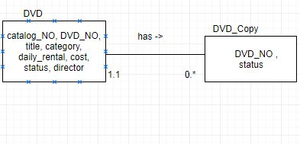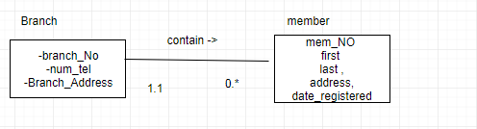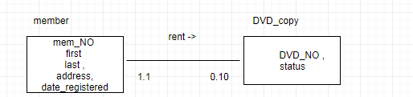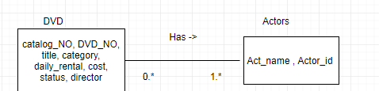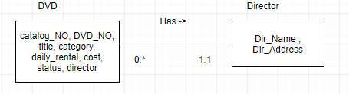

(e) Determine candidate and primary key attributes for each (strong) entity type.

***PK :***

-branch_Address (street, city, state, zip code )

-branch (branchNO )

-Staff (StaffNo )

-DVD (catalog_NO)

-DVD_Copy (DVD_NO )

-Actors (Actor_id )

we assue that the name is unique for the Director

-Director (Dir_Name )

-member (mem_No )

***Candidate Key :***

we assumethat the name isunique for Actor

Actors (Actor_name )

(f ) Using your answers to parts (a) to (e), attempt to represent the data requirements of the DVD rental company

as a single ER diagram. State any assumptions necessary to support your design.

